# Durable Furnitures

Artistica

## Essentials Round Coffee Table

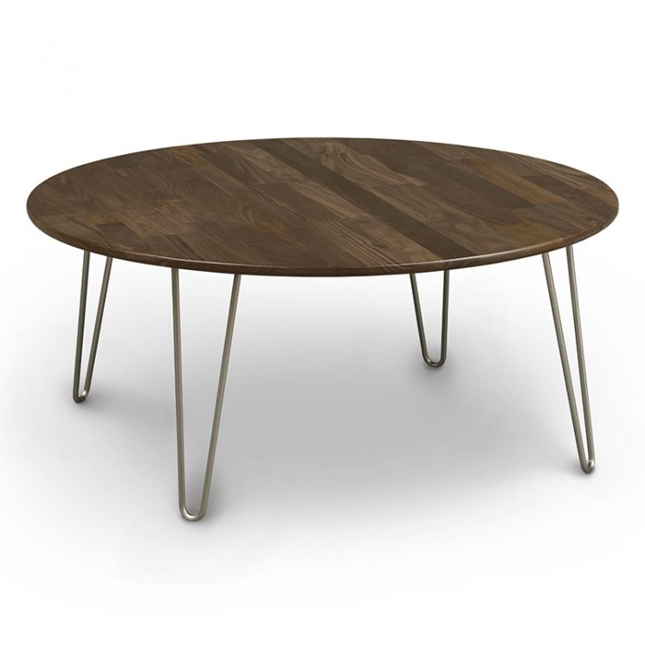

Mid-century modern design that embraces genuine American craftsmanship. Our Essentials Round Coffee Table blends natural walnut or cherry hardwood and industrial metal to create a retro style right out of the 1950s. Expertly constructed in Vermont using sustainably harvest materials, every coffee table is made-to-order just for you.